Excel Assignment - 8

1. What do you mean by AutoComplete feature in Excel and what are the benefits of using this feature?

AutoComplete is the automatic filling in of your text when you start typing and is switched on by default.  
This will reduce the amount of text you have to enter by preventing you typing in repetitive words.  
AutoComplete matches only exact cell entries, not individual words in a cell

------------------------------------------------------------------------------------------------------------------------

1. Explain working with workbooks and working with cells.

A workbook is a spreadsheet program file that you create in Excel. A workbook contains one or more worksheets. A worksheet (also known as a spreadsheet) consists of cells in which you can enter and calculate data. The cells are organized into columns and rows

1. What is fill handle in Excel and why do we use it?

Fill Handle is a feature in Excel that enables you to auto-complete a list in a row/column by simply dragging it using your mouse.

4. 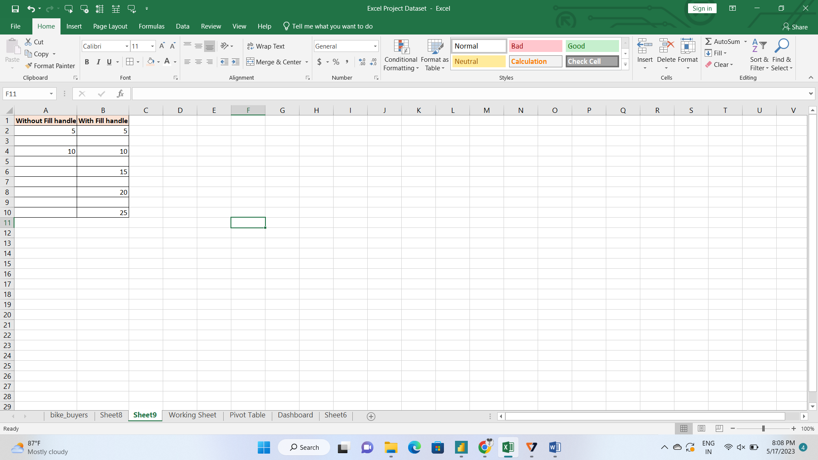

5. Describe flash fill and what the different ways to access the flash fill are.

Excel Flash Fill is a special tool that analyzes the information you are entering and automatically fills data when it identifies a pattern.

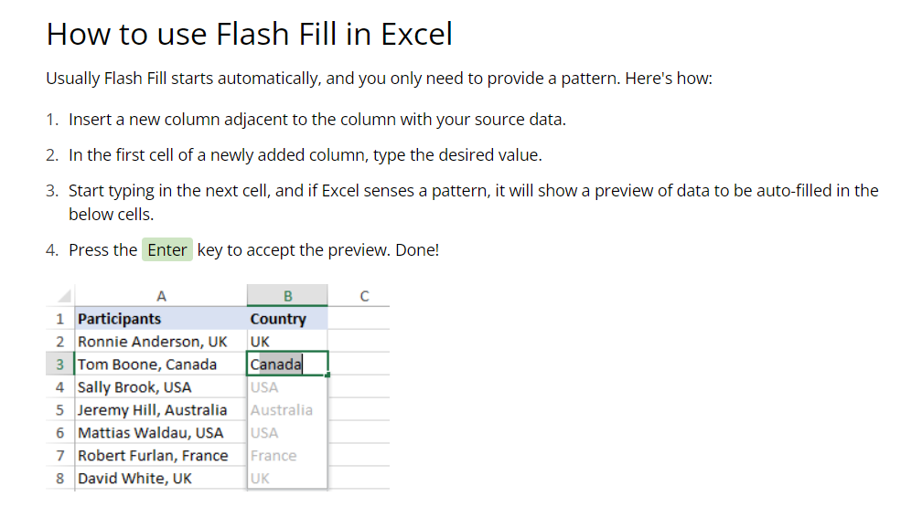

6. Extract first name and last name from the mail id and then from the address column, extract the city, state, and pin code using the flash fill. Given below is an example of the columns you have to create. Paste the screenshot of what you have created using the flash fill command. Example: Mail Id, Address, First name, Last name, State, City, Pincode

